Replication of material based IDOC

You are an end user and need to determine within the MDG Hub details about numbers of certain master data objects. You are also responsible for performing replications of master data objects

Copy a material

i) Open NWBC

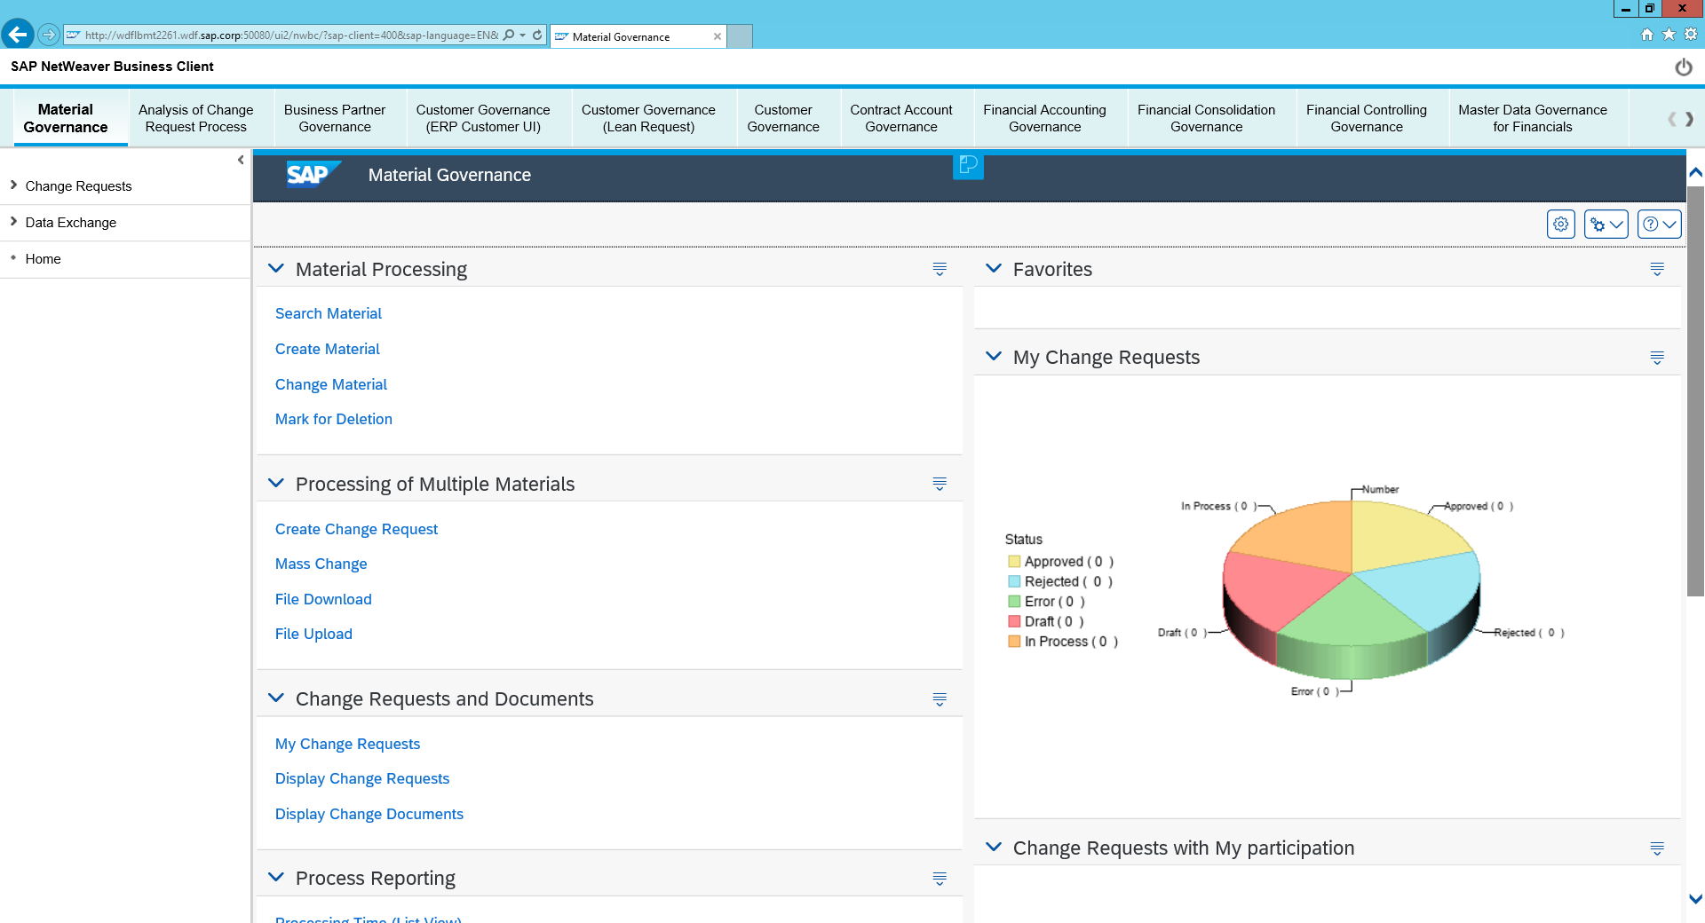

ii) Click Search material

iii)Search for material T-MDG101-01 🡪 Select the material 🡪 Choose copy

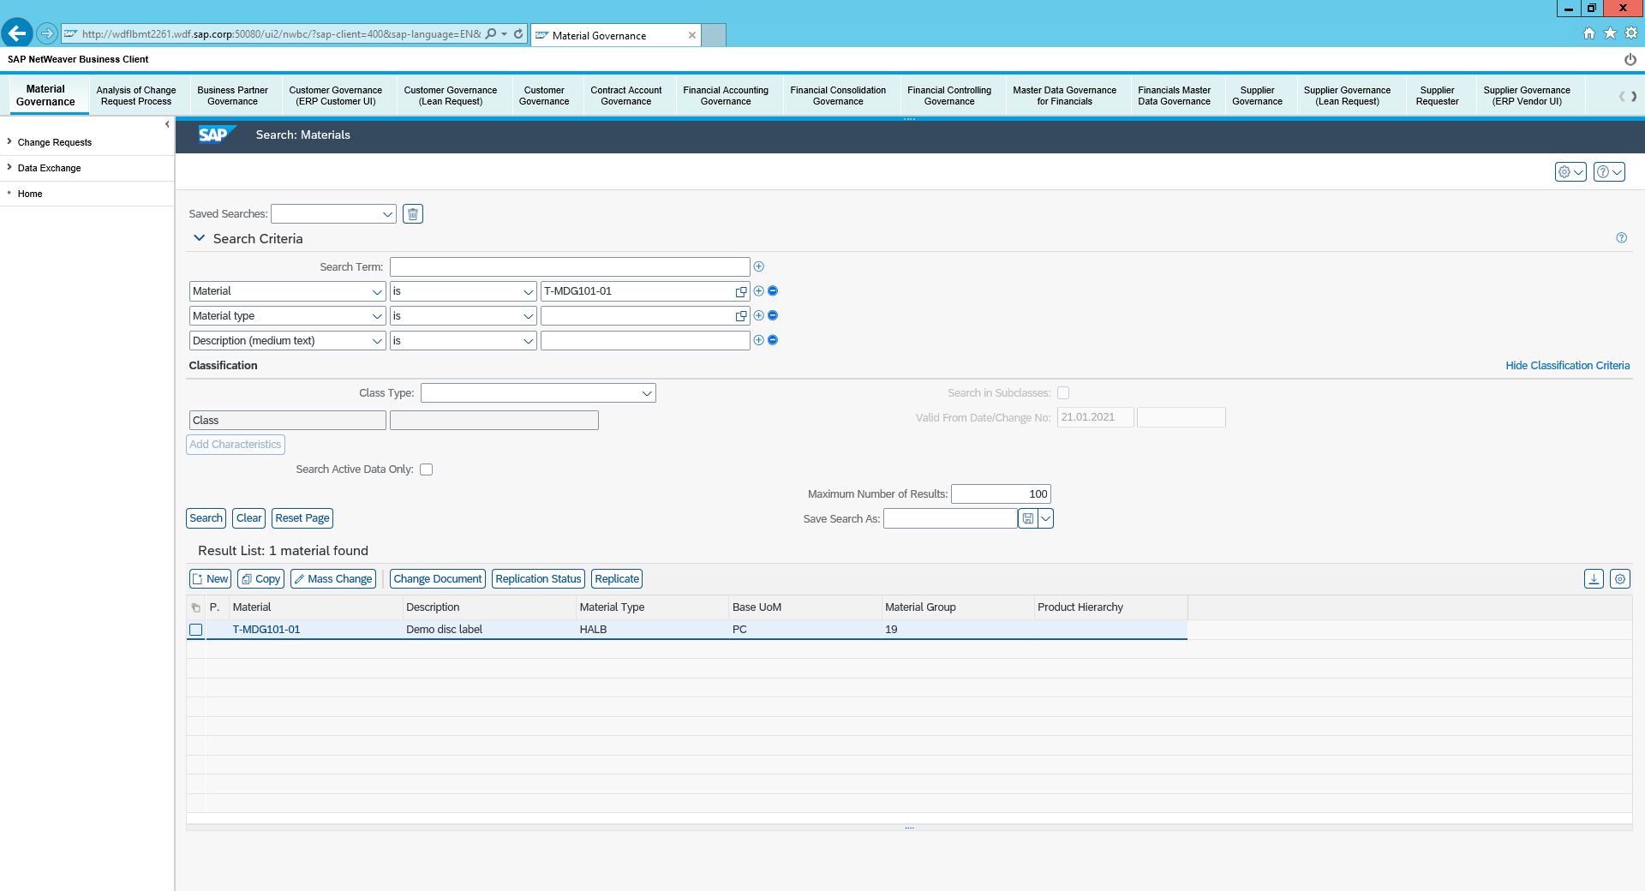

iv) Ensure the details are entered as follows:

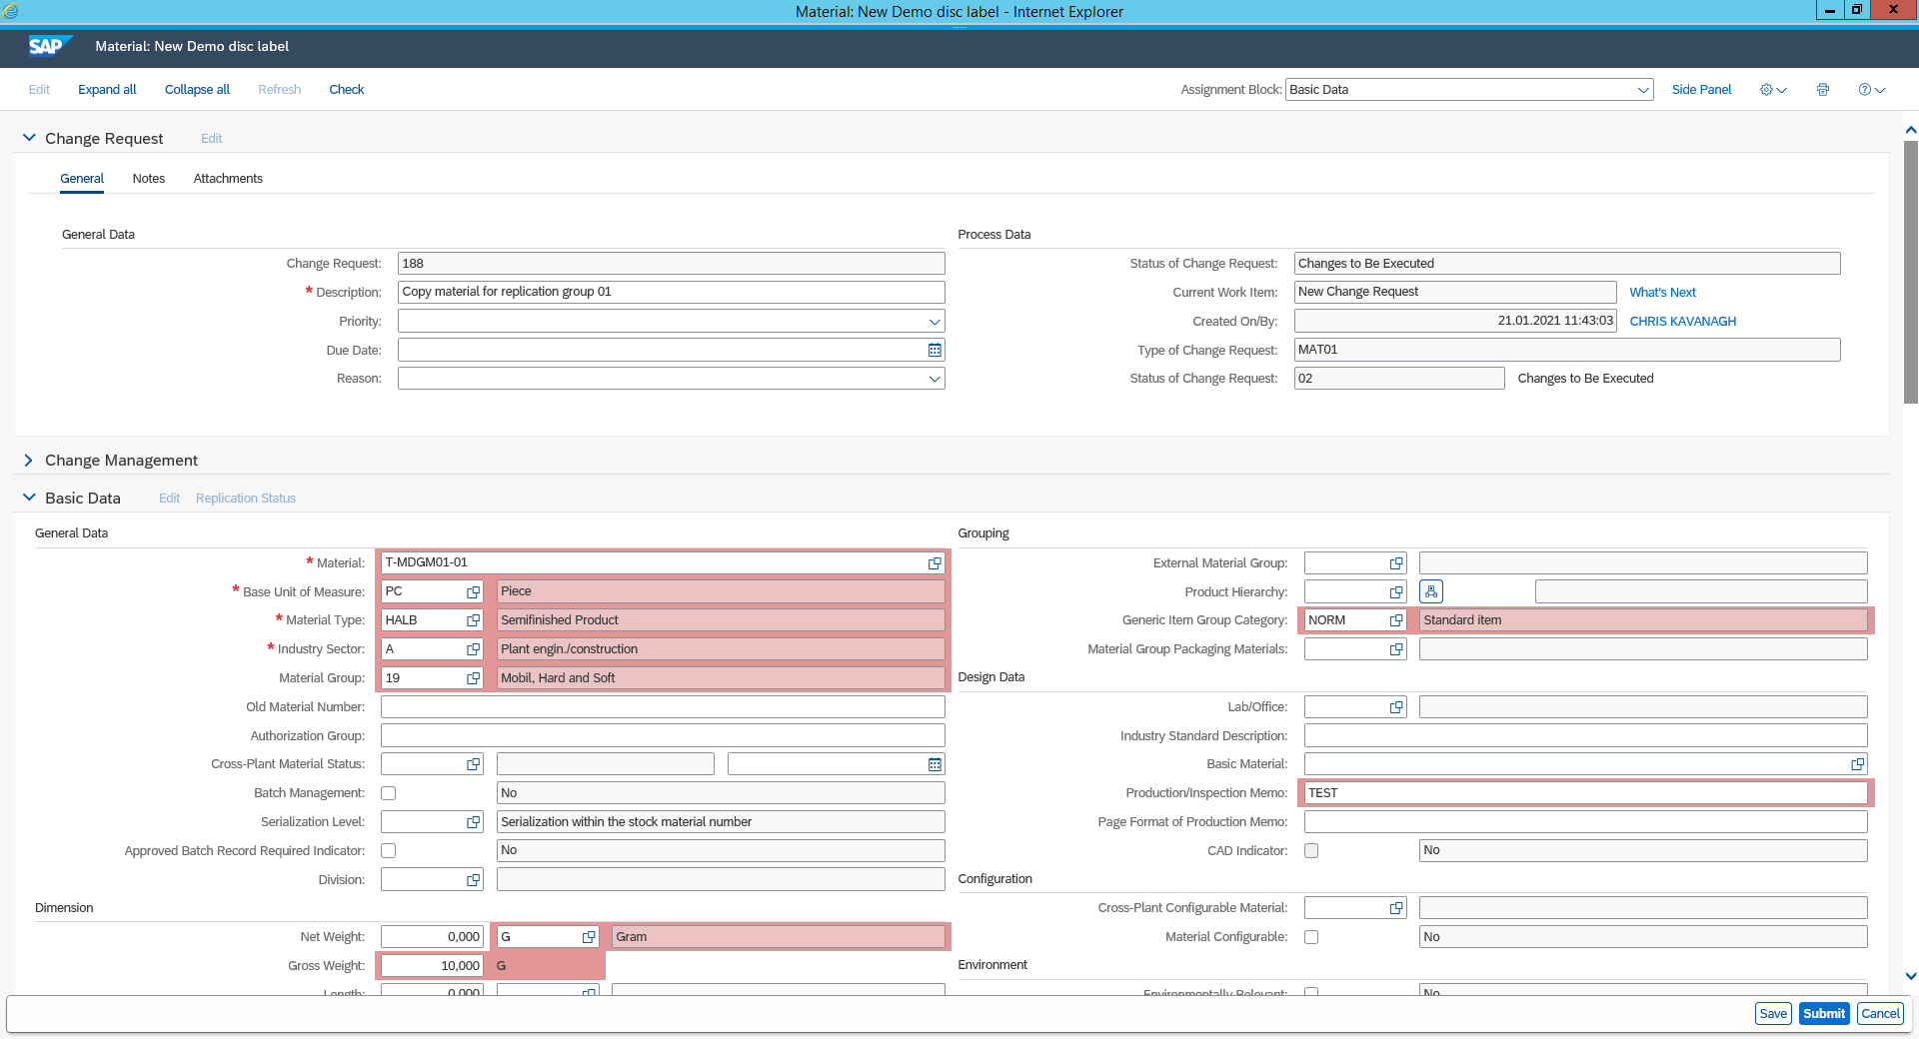

v) Submit the material 🡪 Click the refresh button at the top of the page 🡪Activate The material

Create a new Material

i)Return to the nwbc menu click create material 🡪 Create a new material named “MATSX_GROUP01”

ii) Enter the details as follows:

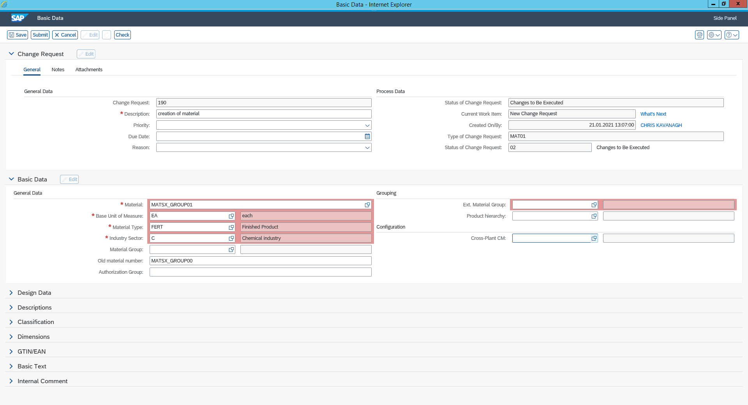

iii) Submit and activate the material

iv) Return to the NWBC Material governance page and search materials 🡪 Search for T-MDG101* 🡪 Select the material T-MDG101-01 🡪 Choose Copy 🡪 save, submit and activate the material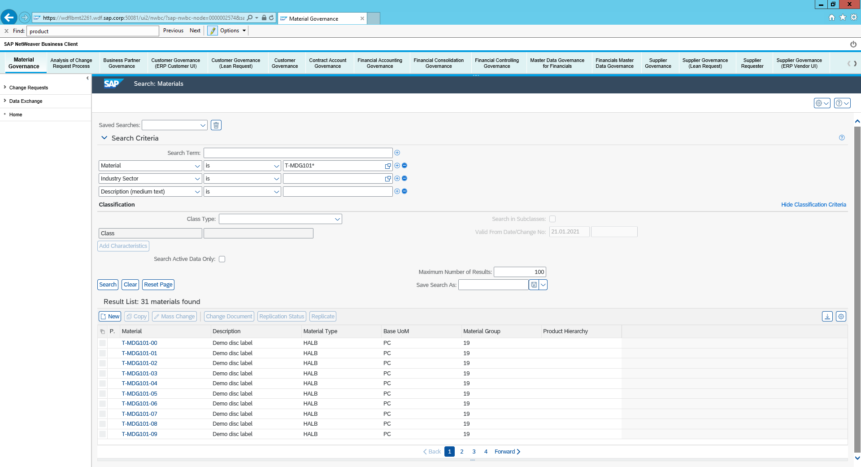

Replicate the material

i) Return to search material 🡪 Search material T-MDG*01

ii) Select material T-MDGM01-01 🡪 Click Replicate

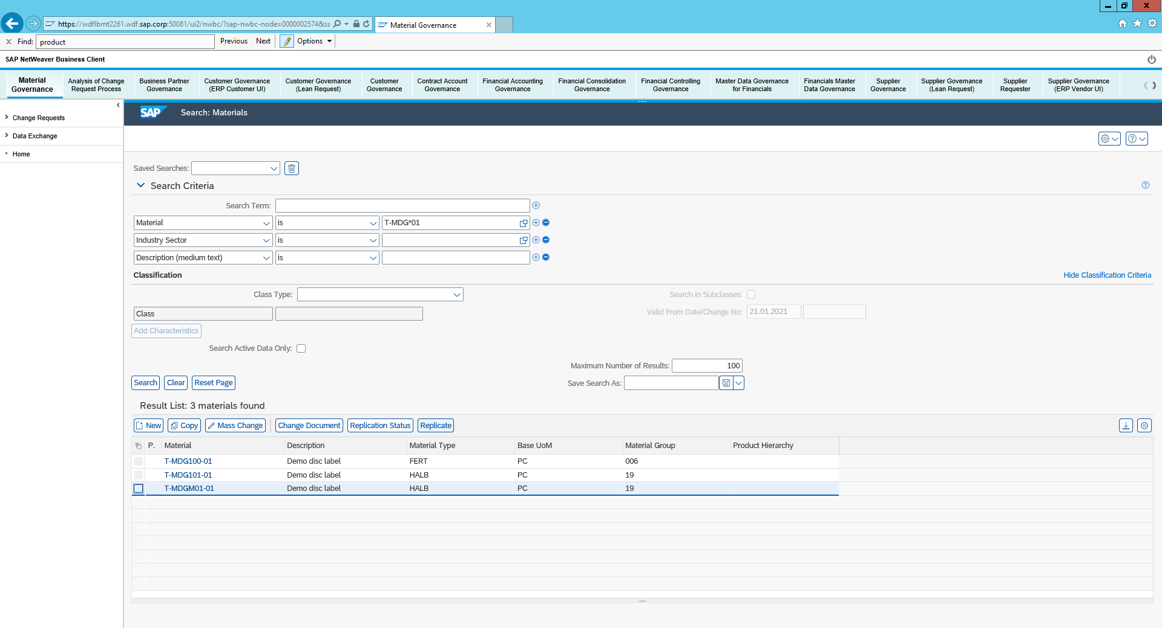

Initiate a manual replication of your material to system T41 Client401

i) Select the check box under Target system Selection and choose replicate in the bottom corner

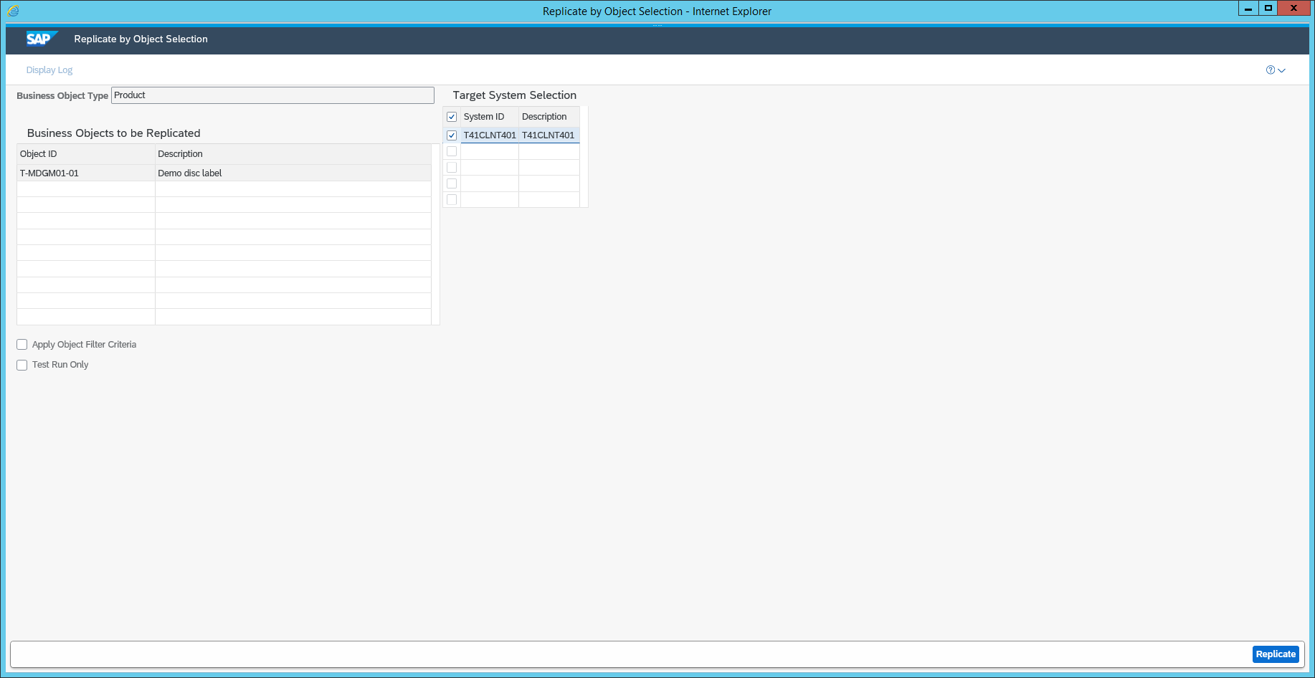

In the following steps you will verify the result and logs of the data replication via IDoc in T41-401

ii) Click display logs in the top left Corner

iii) You can now check the details of the log entries for the replication

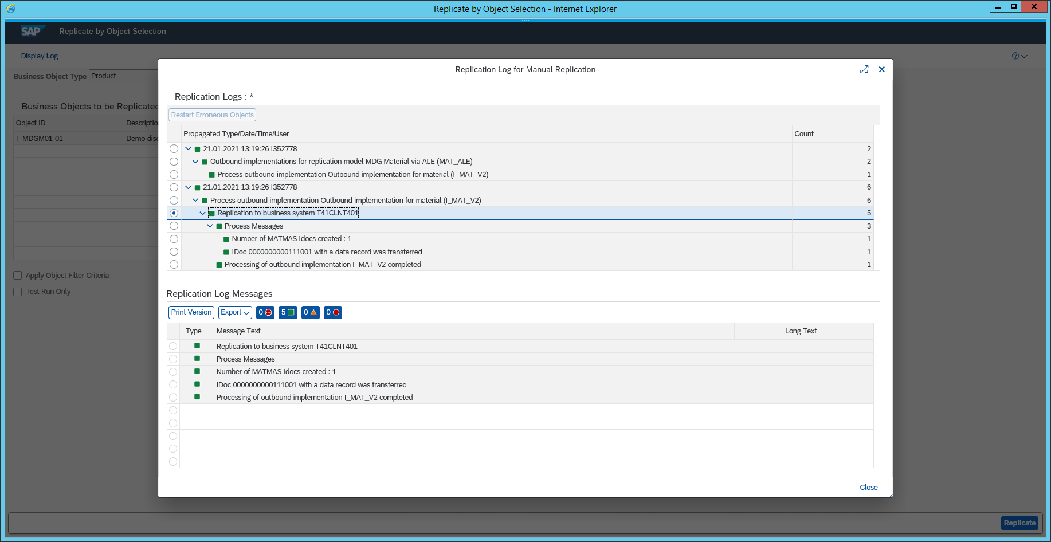

iv) Return to the SAP Easy Access System 🡪 Search for Transaction code BD87 🡪 Choose execute